**PhenoMiner User Submission Help Document**

This document is intended to help users through the process of submitting data to the Rat Genome Database (RGD) for display in the PhenoMiner tool. Some fields are required, while other fields are optional but highly recommended. These optional fields add helpful information that will allow the Curators to accurately map the data to the correct term/measurement. Please upload your protocol/methods for experiment.

**Step 1--Submission Info Form** *(found on Experiment & Submitter Info tab)*

Download and fill out form with experiment information (**1.**). Fill in the contact information for the Principal Investigator/Lab (**2.**) as well as the Submitter in case of questions. The fields are marked either required or recommended. The "Sex" and "Individual/Summary Data" fields have drop down boxes to simplify your choice. You will find links to the Strain Search Page and Strain Query Form at the bottom of the form (**3.**). If you can’t find your strain on the RGD website strain list or would like to register a new strain visit <http://rgd.mcw.edu/rgdweb/models/strainSubmissionForm.html?new=true> to find the online registration form. If data was collected from a new stain, please register your strain prior to submitting phenotype data. Please contact RGD with any questions about the data load (**4.**).

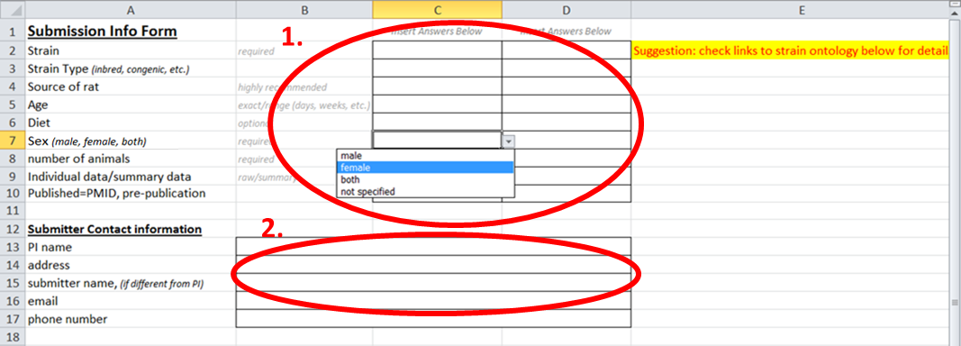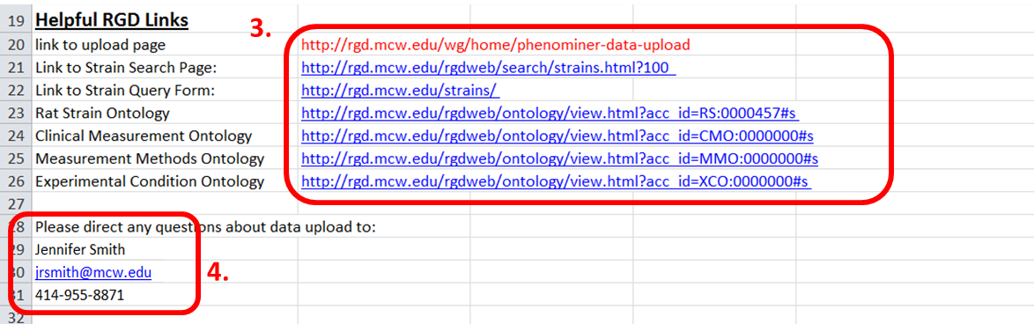

**Step 2--Data Submission**

**Summary Data Load:** *Found on Summary Phenotype Data tab*

Examples of data are provided in greyed-out rows. (**1.**) Please do not put your data in the grey rows. Enter data starting in Row 7. Enter the Clinical Measurement (required)(**2.**), and Clinical Measurement Ontology ID (optional). Click the link in the Colum Header to browse or search the Clinical Measurement Ontology (**3.**). Clinical Measurements are phenotype measurements that are made during an experiment. Examples: heart rate, blood cell count, serum total cholesterol level. Enter the units for the Clinical Measurement previously chosen (required) (**4.**). If your measurement is a calculated ratio, for example organ weight (g) to body weight (g) ratio, please enter the unit ratio (g/g). If the term you need is not available please email [RGD.DATA@mcw.edu](mailto:RGD.DATA@mcw.edu) to register a new term or ask for suggestions.

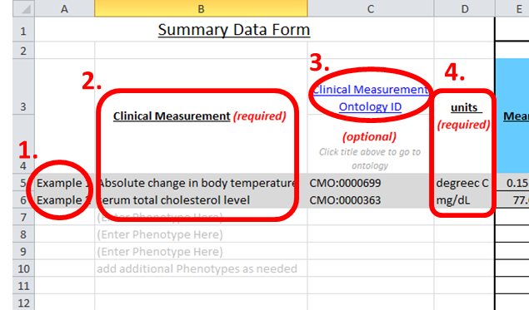

Enter the Strain for each group of measurements (**5.**) This template is created with space for 3 groups (**6.**).

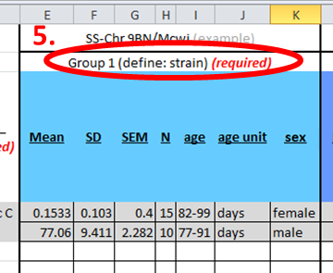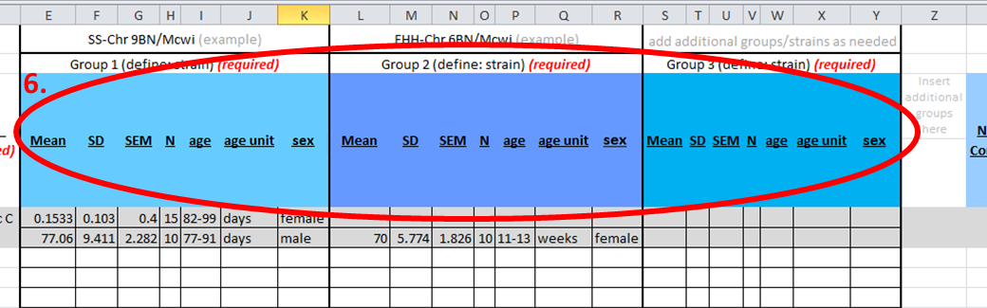

If your study/experiment has more than 3 groups, copy the 7 columns that make up a group (**7.**) and insert copied columns as needed in column Z. (**8.**)

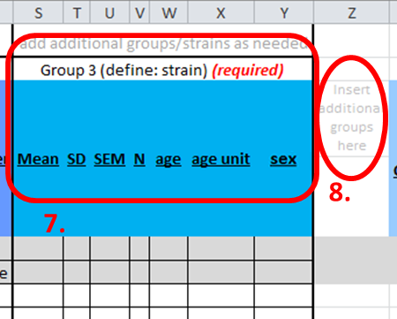

Entering Data for each group (**9.**): Please enter the mean for each group. Enter the Standard Deviation **and/or** the Standard Error for the group. We need at least one of these measurements to graph the results. Enter the number of animals for each group. Next, enter the age of the animals at the time of the measurement. Please include the age unit (ex. days, weeks, months).

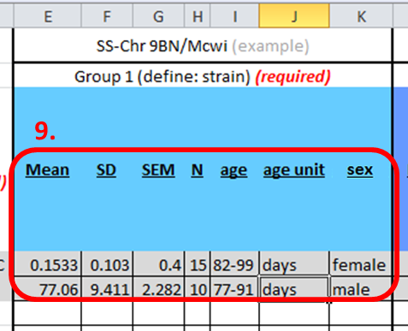

Enter Measurement Method (required) (**10.**) and Measurement Method Ontology ID (optional) (click on column header to go to the Measurement Method Ontology). Enter Measurement Method Site (optional). A Measurement Method describes how the individual phenotype was obtained. Examples: fluid filled catheter, blood chemistry panel, radiotelemetry, radioimmunoassay, etc.

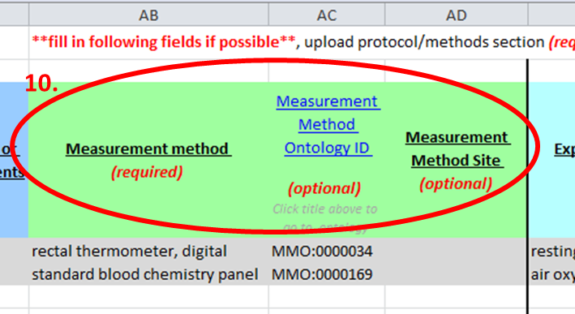

Enter Experimental Condition 1 (required) (**11.**) and Experimental Condition 1 Ontology ID (optional). The Experimental Method describes the conditions of the experiment both before and during the measurement. Examples: diet, atmosphere composition, activity level, etc. Click on Condition Ontology ID column header to go to Clinical Condition Ontology.

Enter Experimental Condition 1 Value (optional) (**12.**) and Experimental Condition Length/Duration (required).

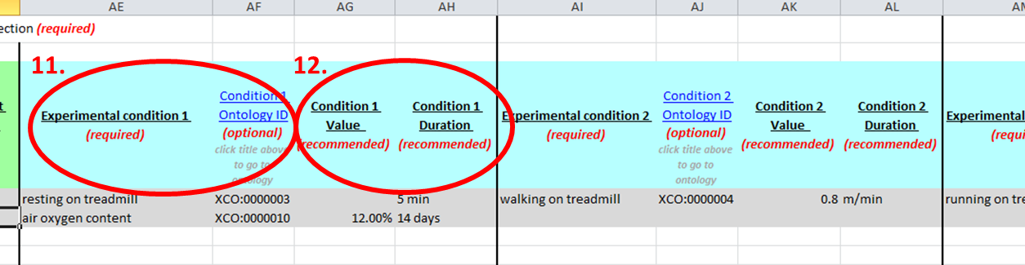

Continue to add experimental conditions as above. The template has space for 4 different Experimental Conditions but more Conditions/columns may be added as needed.

**Individual Data Load:** *Found on Individual Data Load Tab*

Examples of Data are provided in greyed-out rows. (**1.**) Please do not put your data in the grey rows. Enter Clinical Measurement (required) (**2.**) and Clinical Measurements Ontology ID (optional). Click on the Clinical Measurement Ontology ID column header to browse or search the Clinical Measurement Ontology.

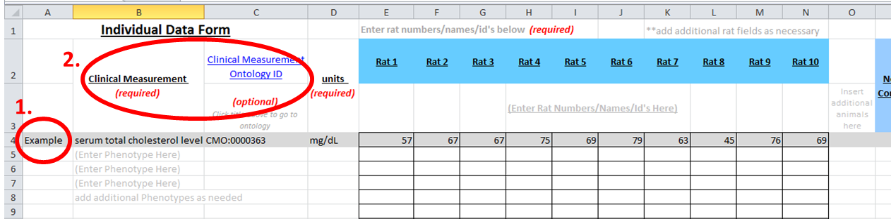

Enter the units for the Clinical Measurement previously chosen (required) (**3.**) Enter Rat Numbers/Names/ID’s (required)(**4.**) Additional Rat Fields can be added as necessary (**5.**)

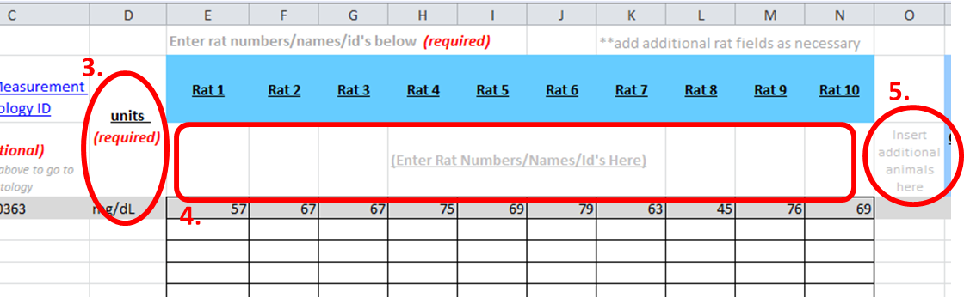

Enter Measurement Method (required) (**6.**) Measurement Method Ontology ID (optional)

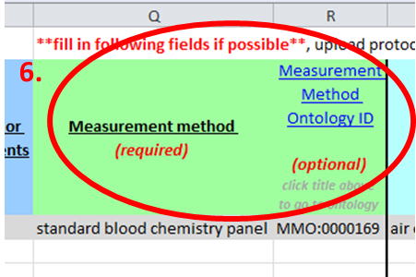

Enter Experimental Condition 1 (required) (**7.**) and Experimental Condition 1 Ontology ID (optional). If the animals have not been subjected to any conditions other than standard food, water, housing, etc., condition 1 will be "naïve control". Enter Experimental Condition 1 Value (**8.**) and Experimental Condition Length/Duration, if applicable.

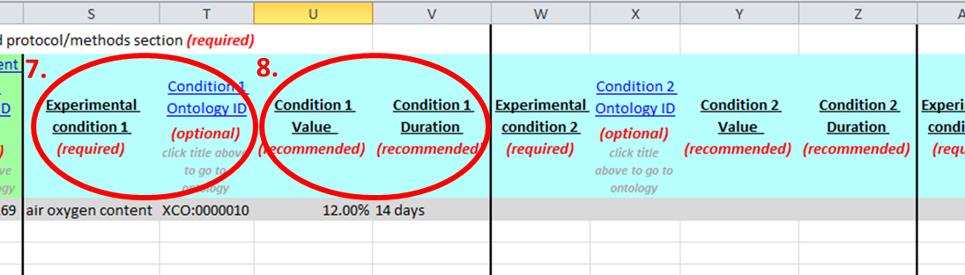

Continue to add experimental conditions as above. The template has space for 4 different Experimental Conditions but more Conditions/columns may be added as needed.

**Saving Instructions**

Save file with the following format:

PI name_experiment_[date submitted]

Example: Smith_high salt blood pressure_5-12-12